SETUP TO PREVENT ECOMMERCE 3DS ATTEMPT TRANSACTION

1. Setup Additional Service Pack
2. Navigate ROOT > OpenWay > Full > Configuration Setup > Products > Service Packs
3. Duplicate “001-Add JCB Credit Ecommerce Prevention” Service Pack
   * Update name of duplicate service pack to “001-Add JCB Credit Ecommerce 3DS Attempt Prevention”
   * Update code of duplicate service pack. Code is unique
   * Update condition to prevent ecommerce 3DS attempt
     + Click “Target” tab
     + Update condition to <<All Secure Attempt (Group)>> for all records
     + Click “Save form changes”
   * Approve a new additional service pack
4. Continue doing for “001-Add MC Credit Ecommerce 3DS Attempt Prevention”, “001-Add JCB Debit Ecommerce 3DS Attempt Prevention”, “001-Add MC Debit Ecommerce 3DS Attempt Prevention” and “001- Add MC Prepaid Ecommerce 3DS Attempt Prevention”

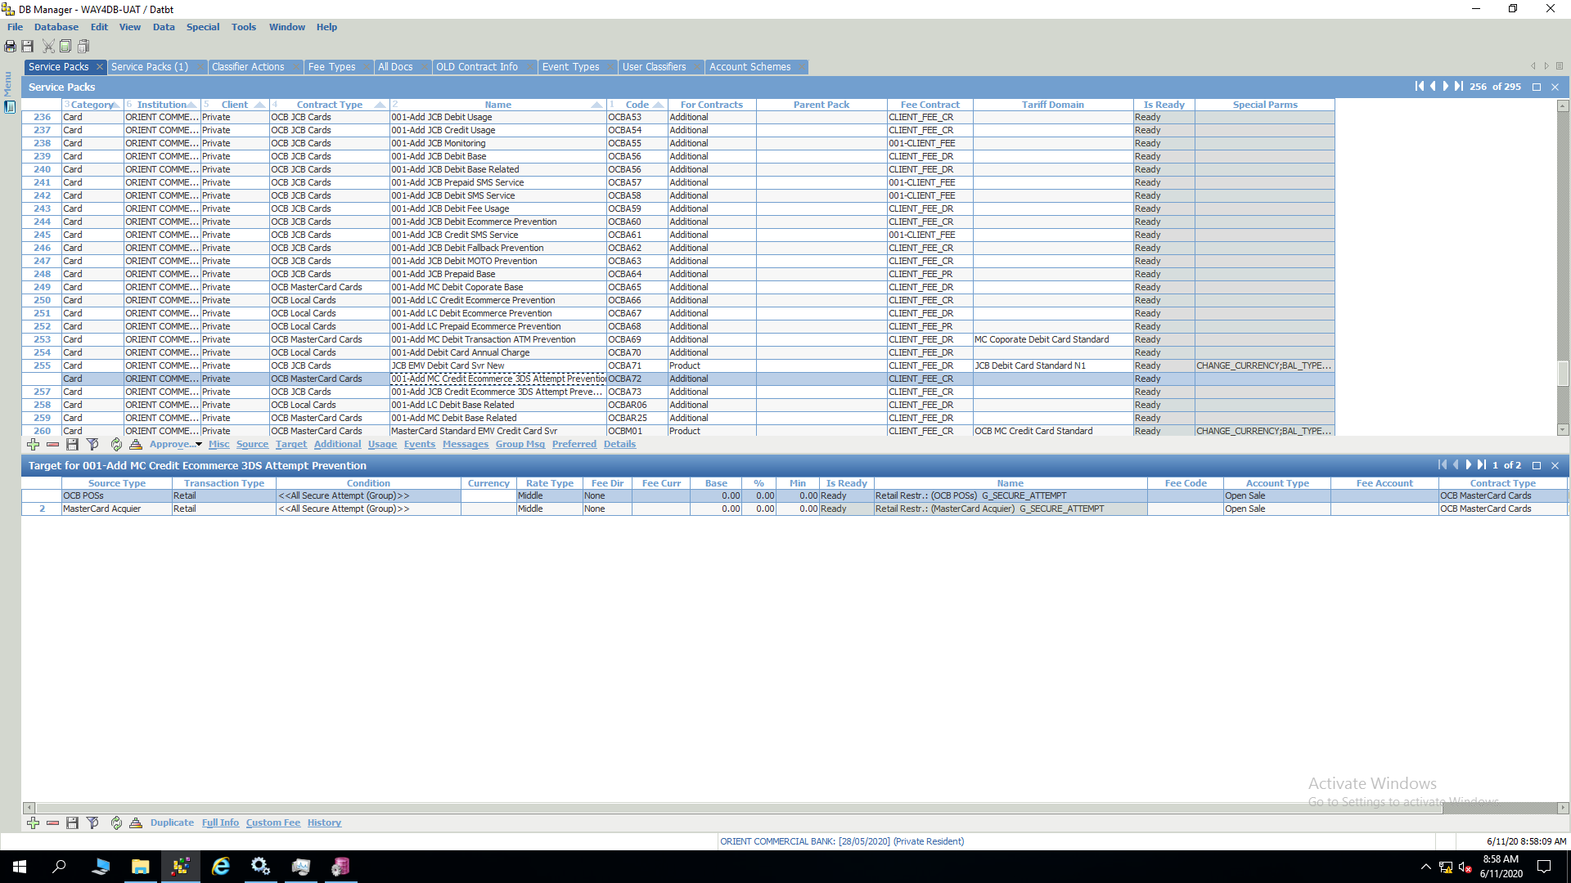

1. Add Additional Service Pack Into Product Service Pack
2. Navigate ROOT > OpenWay > Full > Configuration Setup > Products > Service Packs
3. Add “001-Add JCB Credit Ecommerce 3DS Attempt Prevention” additional service pack into “JCB Standard EMV Credit Card Svr”, “JCB Gold EMV Credit Card Svr”, “JCB Platinum EMV Credit Card Svr”, “JCB Standard EMV COMB Credit Card Svr”, “JCB Gold EMV ComB Credit Card Svr”, “JCB EMV TTC Hospitality Credit Card Svr” product service pack
   * Select each product service pack
   * Click “Additional” tab
   * Click “Insert new record”
   * Input values
     + Priority=120
     + Add pack=001-Add JCB Credit Ecommerce 3DS Attempt Prevention
     + Is ready=ready
     + Active by default=yes
   * Click “Save form changes”
   * Approve product service pack
4. Add “001-Add JCB Debit Ecommerce 3DS Attempt Prevention” additional service pack into “JCB EMV Debit Card Svr”, “JCB EMV Debit Card Svr New” product service pack
   * Select each product service pack
   * Click “Additional” tab
   * Click “Insert new record”
   * Input values
     + Priority=120
     + Add pack=001-Add JCB Debit Ecommerce 3DS Attempt Prevention
     + Is ready=ready
     + Active by default=yes
   * Click “Save form changes”
   * Approve product service pack
5. Add “001-Add MC Credit Ecommerce 3DS Attempt Prevention” additional service pack into “MasterCard Standard EMV Credit Card Svr”, “MasterCard Gold EMV Credit Card Svr”, “MasterCard PLT EMV Credit Card Svr”, “MasterCard Priority EMV Credit Card Svr”, “MasterCard Gold Priority EMV Credit Card Svr”, “MasterCard Coporate World EMV Credit Std Card Svr”, “MasterCard Coporate Platinum EMV Credit Std Card Svr” product service pack
   * Select each product service pack
   * Click “Additional” tab
   * Click “Insert new record”
   * Input values
     + Priority=120
     + Add pack=001-Add MC Credit Ecommerce 3DS Attempt Prevention
     + Is ready=ready
     + Active by default=yes
   * Click “Save form changes”
   * Approve product service pack
6. Add “001-Add MC Debit Ecommerce 3DS Attempt Prevention” additional service pack into “MasterCard EMV Debit Standard Card Svr”, “MasterCard EMV Debit Gold Card Svr”, “MasterCard Coporate EMV Debit Card Svr” product service pack
   * Select each product service pack
   * Click “Additional” tab
   * Click “Insert new record”
   * Input values
     + Priority=120
     + Add pack=001-Add MC Debit Ecommerce 3DS Attempt Prevention
     + Is ready=ready
     + Active by default=yes
   * Click “Save form changes”
7. Approve product service pack Add “001-Add MC Debit Ecommerce 3DS Attempt Prevention” additional service pack into “MasterCard EMV Prepaid Card Svr”, “MasterCard MAG Prepaid Card Svr” product service pack
   * Select each product service pack
   * Click “Additional” tab
   * Click “Insert new record”
   * Input values
     + Priority=120
     + Add pack=001-Add MC Prepaid Ecommerce 3DS Attempt Prevention
     + Is ready=ready
     + Active by default=yes
   * Click “Save form changes”
   * Approve product service pack

